Implementation:

1. Open Terminal on Jupyter Notebook
2. Use command “python server.py” to start server
3. Open new Terminal
4. Use command “python client.py” to connect client to server
5. Once connection is established:

* Send message using “<Message>”
* To disconnect type “Quit”

PFA image below for Client and Server terminal outputs

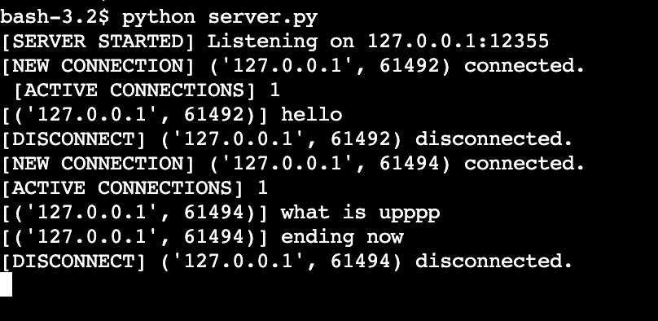

Server Side chatbox from terminal

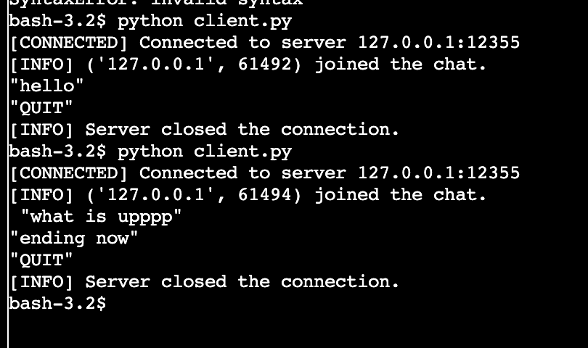

Client Side chatbox from terminal